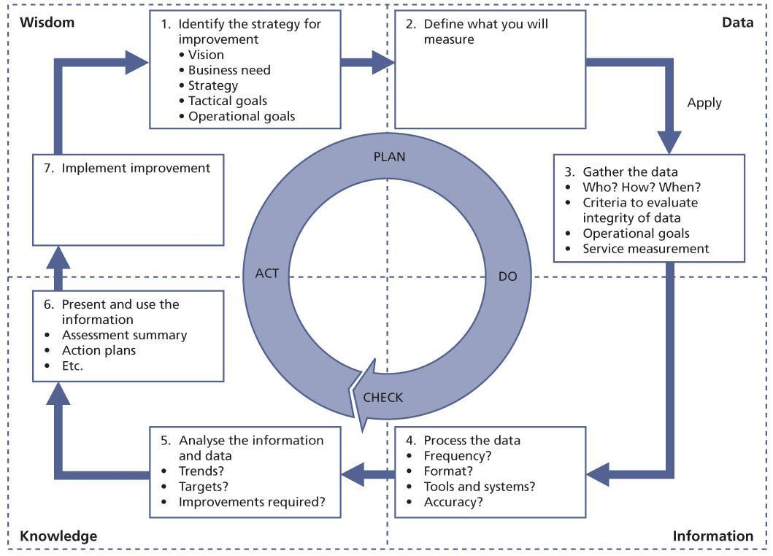

The seven-step improvement process

* Plan

1. Identify the strategy for improvement

2. Define what you will measure

* Do

3. Gather the data

4. Process the data

* Check

5. Analyse the information and data

6. Present and use the information

* Act

7. Implement improvement.